Coastline sensitivity analysis – description of delivery

Version 1.0: 2016.05.25:
Innhold
structure of fme workspaces 3
Installation and use 4
how to add a new ranking 5

Installation and use
- Software needed:
  - FME Desktop 2016
  - QGIS
  - MS Excel
- Data needed:
  - Inputdata
  - Excel-files for templates:
    - Part1b_Dataset preparation_Convert_to_specific_datatypes_ranking_table.xlsx
      - This describes the mapping to specific ranks
    - Results_ranking_template.xls
      - This decribes the look of the Results_ranking.xls that will contain the end-result.

structure of fme workspaces
The FME workspaces should be self-explanatory – however a brief description of the different parts can be found in this document.
The delivered workspaces are:
- Part1a_Dataset preparation_Import_data: Takes a catalogue with files and imports them to a SQLITE filedatabase. Converts everything to Coordinate system: EPSG:4326 and keeps all attributes. Takes approx. 30 minutes to process all input-files delivered to a 130 MB sqlite database.
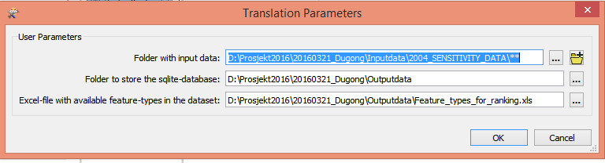
- Part1b_Dataset preparation_Convert_to_specific_datatypes: Uses Part1b_Dataset preparation_Convert_to_specific_datatypes_ranking_table.xlsx to convert to defined schema. This workspace attaches the ID (for instance H1,H2,H3, E1,E2,E3 to spatial features) to relevant and creates a table called H1,H2,E1,E2 etc with each feature.
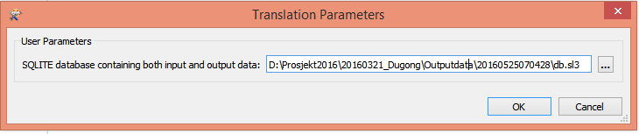
- Part2_Shoreline_simplification: Generates a generalized shoreline with user input values defining the buffer and the length of each segment. Creates 3 features, generalized_shoreline, generalized_shoreline_text, generalized_buffer
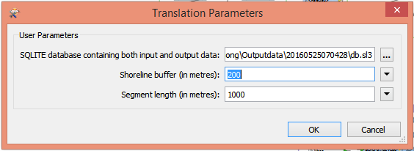

- Part3_Result_generate_output: Takes the buffered areas from the generalized shoreline and overlays them with the data to produce output-files according to specifications.
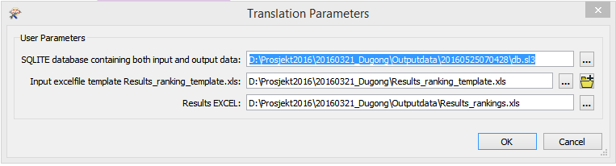

how to add a new ranking
- Open up Part1b_Dataset preparation_Convert_to_specific_datatypes_ranking_table.xlsx
Choose the correct Sheet – Human use or Ecology
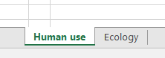
and find the existing ID or create a new row with your dataset.
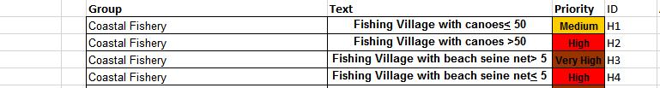
- Delete everything on row 28 – 35
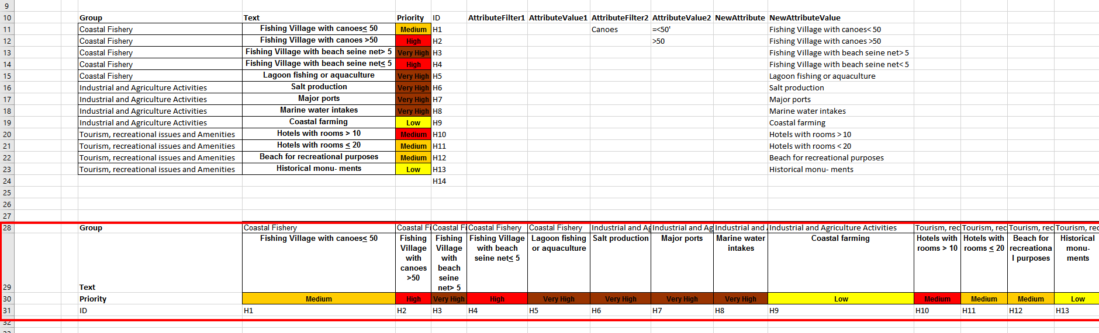
- Mark your new text – right click and COPY:
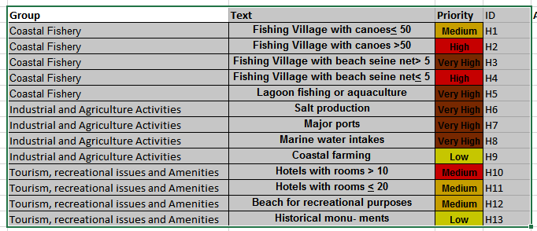
- You also need to update the Results_ranking_template.xls with the new data – so open this file on the correct sheet (Ecology or Human Use) – Paste the data from row 7A. Choose Options at the lower right () and the change rows / columns
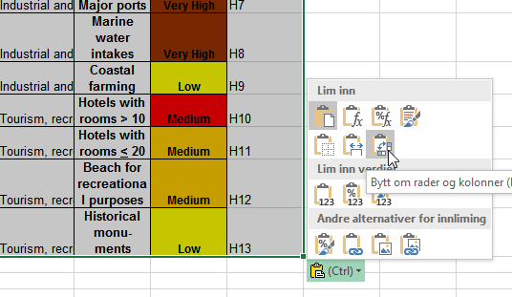
The rows should now be aligned as columns like this:
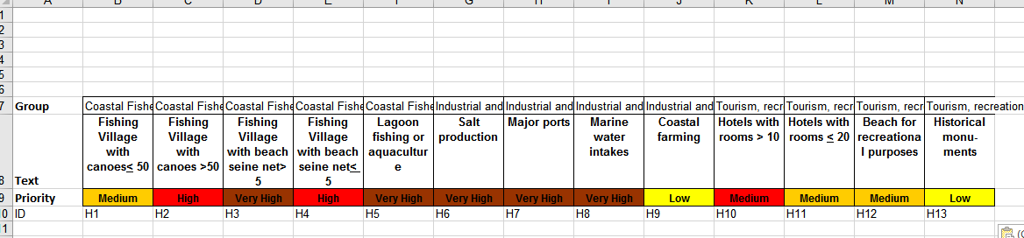
- Open up Part1b_Dataset preparation_Convert_to_specific_datatypes.fmw in FME Workbench.
- Enable all features within the bookmark “Available Features” and look at the data in FME Data Inspector
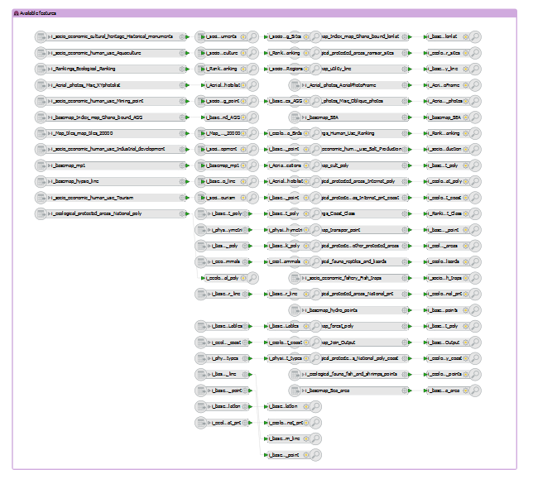
- Examine the data in the FME Data Inspector and find the feature that represents the dataset that you want to add
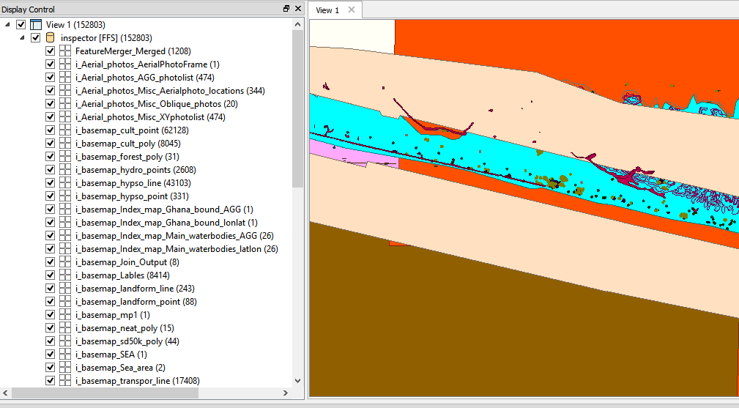
- Find this dataset and move it to Ecology or Human Use Bookmark, now disable all the other features and run the workspace to confirm you have found the correct dataset you want to work with.
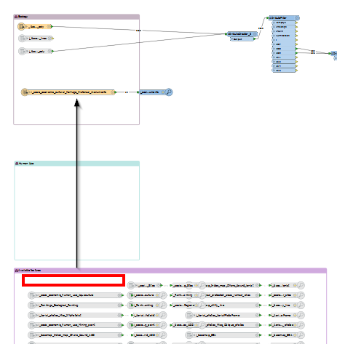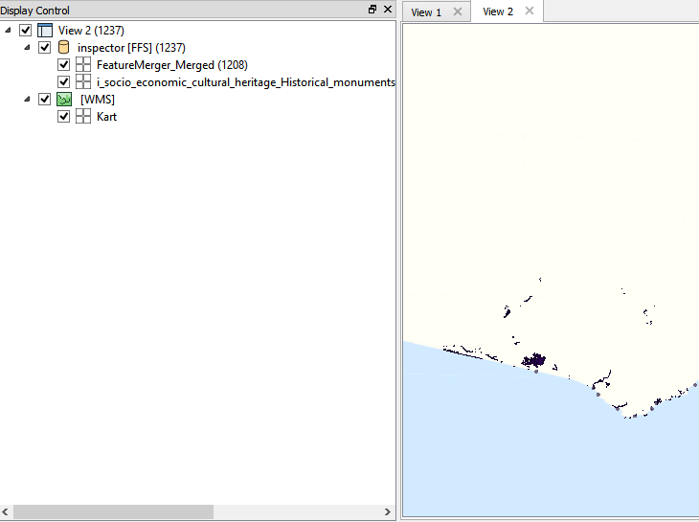
- Add the logic you need to filter out the correct features you want tagged and copy the AttributeCreator_3 which is within the Bookmark called “Add Rank”. Edit this new Transformer and change the Attribute Value on the fme_feature_type to the correct one from the Excel-sheet. For instance below it is set to E7, which in the Excel-sheet is defined as:
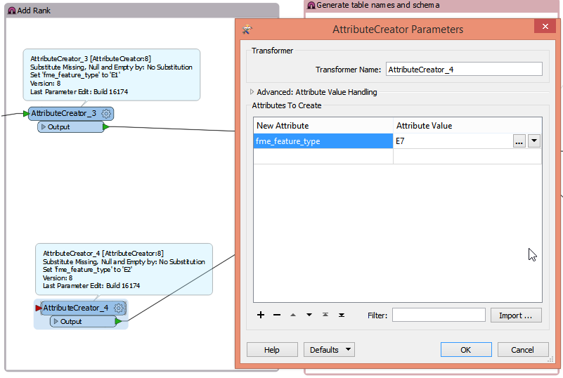

- Run the workspace and verify by opening the sdqlite in FME Data Inspector that there is now a table/feature called E7 (or the value you entered). You can also examine the logfile to see if the features was written:
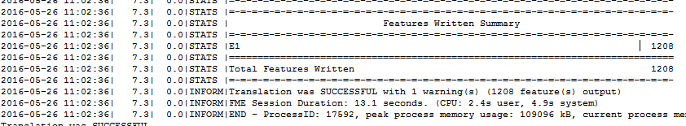
- If you want to change the shoreline buffer or length, run the Part2_Shoreline_simplification.fmw with the new values.
- Open Part3_Result_generate_output.fmw.
- Do Readers – Import Feature Types . And find your newly created Table (E7)
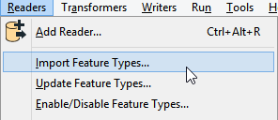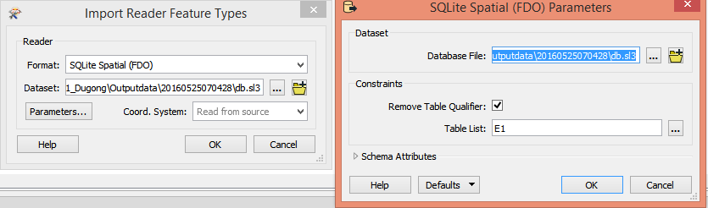
- Connect this new Featuretype/Table to the AttributeCreator
- Run the Workspace and the excelfile (Results_rankings.xls) will be updated with data on that column
